Employee Database - Array & Aggregation Operations
Que :- Database name: companyDB
Query :- db.employees.insertMany([
{emp_id:101,name:"Amit",department:"IT",skills:["Python","MongoDB","Docker"],projects:[{name:"HRMS",duration:6,technologies:["NodeJS","MongoDB"]}],salaries:[45000,48000,52000],certifications:["AWS","Azure"]},

{emp_id:102,name:"Neha",department:"HR",skills:["Communication","Recruitment"],projects:[{name:"HiringPortal",duration:4,technologies:["PHP","MySQL"]}],salaries:[35000,38000],certifications:["SHRM"]},

{emp_id:103,name:"Ravi",department:"Finance",skills:["Excel","Tally","SQL"],projects:[{name:"Accounting",duration:10,technologies:["SQL","PowerBI"]}],salaries:[40000,42000,46000],certifications:["CPA","CFA"]},

{emp_id:104,name:"Pooja",department:"IT",skills:["Java","Spring","MongoDB"],projects:[{name:"BankingApp",duration:12,technologies:["Java","MongoDB"]},{name:"CRM",duration:7,technologies:["Spring","MySQL"]}],salaries:[50000,54000,60000],certifications:["Oracle","AWS"]}
])
Output :-
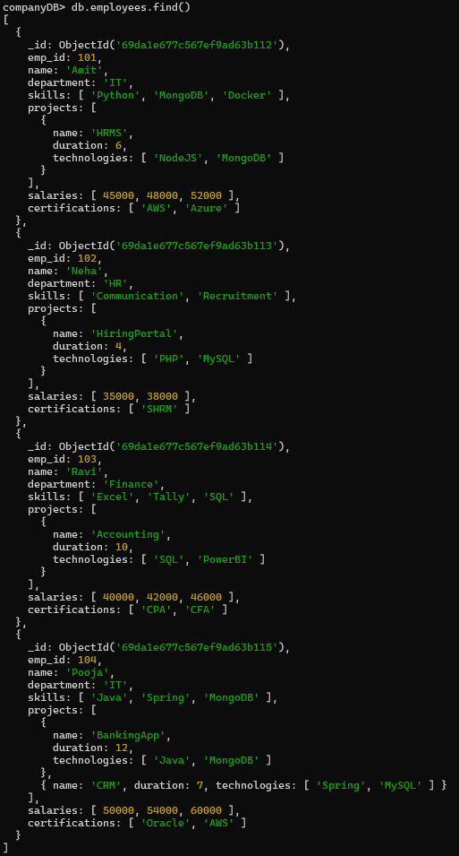
Que.1 :- Display all employees who have MongoDB skill.
Query :- db.employees.find({skills:"MongoDB"})
Output :-
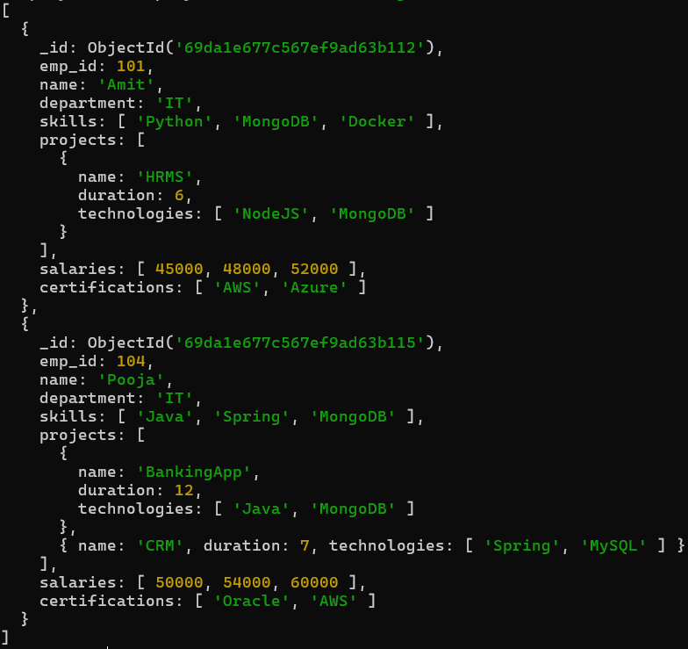
Que.2 :- Find employees having both Python and MongoDB skills.
Query :- db.employees.find({skills:{$all:["MongoDB","Python"]}})
Output :-
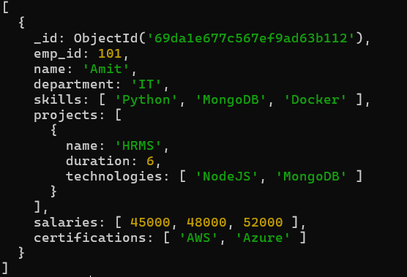
Que.3 :- Display employees with more than 2 skills.
Query :- db.employees.find({$expr:{$gt:[{$size:"$skills"},2]}})
Output :-
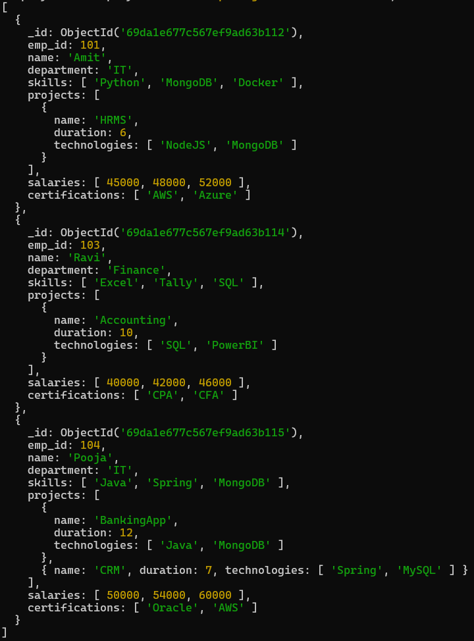

Que.4 :- Add a new skill "Kubernetes" to Amit.
Query :- db.employees.updateOne({name:"Amit"},{$push:{skills:"Kubernetes"}})
Output :- {acknowledged: true,
insertedId: null,
matchedCount: 1,
modifiedCount: 1,
upsertedCount: 0}
Check Query :- db.employees.find()
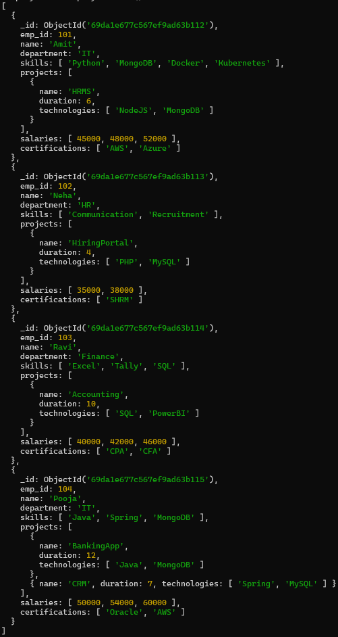
Que.5 :- Add multiple skills to Pooja.
Query :- db.employees.updateOne({name:"Pooja"},{$addToSet:{skills:{$each:["AWS","Docker","Git"]}}})
Output :- {acknowledged: true,
insertedId: null,
matchedCount: 1,
modifiedCount: 1,
upsertedCount: 0}
Check Query :- db.employees.find()
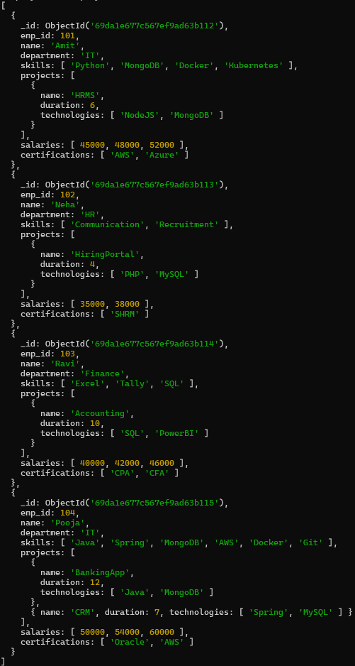

Que.6 :- Add a certification only if not already present.
Query :- db.employees.updateOne({name:"Neha"},{$addToSet:{certifications:"PHP"}})
Output :- {acknowledged: true,
insertedId: null,
matchedCount: 1,
modifiedCount: 1,
upsertedCount: 0}
Check Query :- db.employees.find()
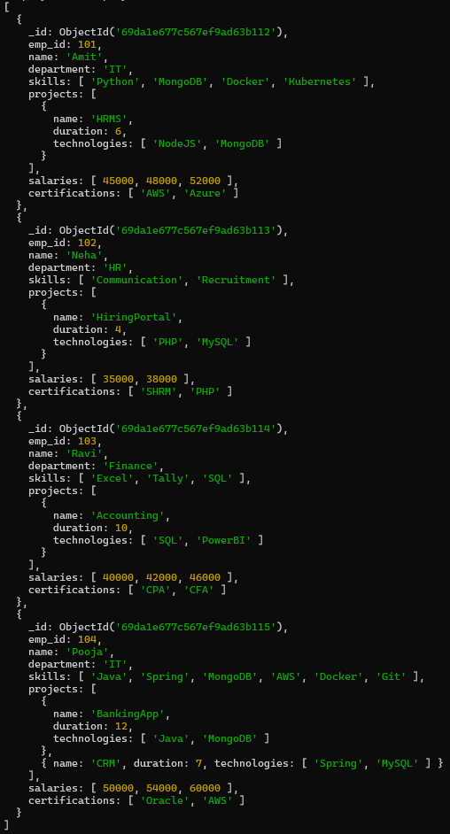

Que.7 :- Remove "Docker" skill from Amit.
Query :- db.employees.updateOne({name:"Amit"},{$pull:{skills:"Docker"}})
Output :- {acknowledged: true,
insertedId: null,
matchedCount: 1,
modifiedCount: 1,
upsertedCount: 0}
Check Query :- db.employees.find()
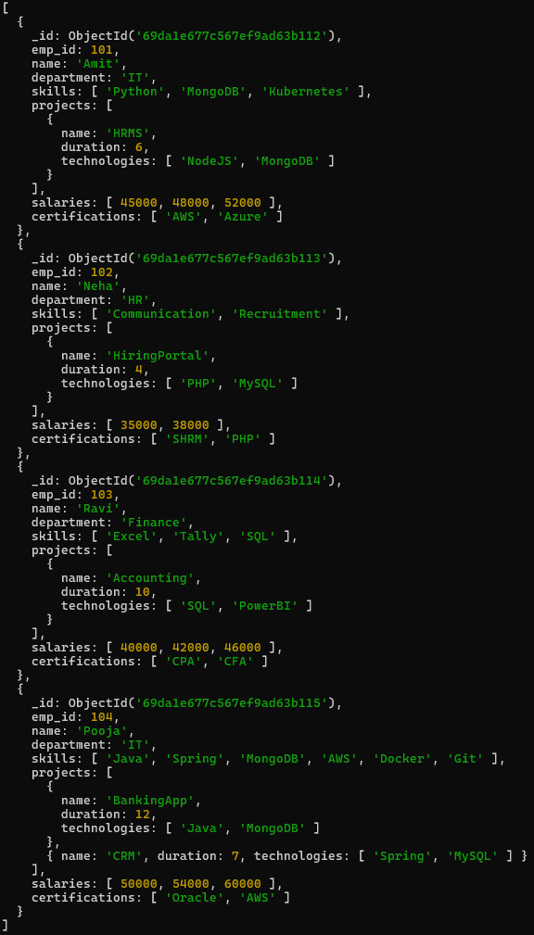

Que.8 :- Remove multiple salaries less than 45000
Query :- db.employees.updateMany({},{$pull:{salaries:{$lt:45000}}})
Output :- {acknowledged: true,
insertedId: null,
matchedCount: 4,
modifiedCount: 2,
upsertedCount: 0}
Check Query :- db.employees.find()
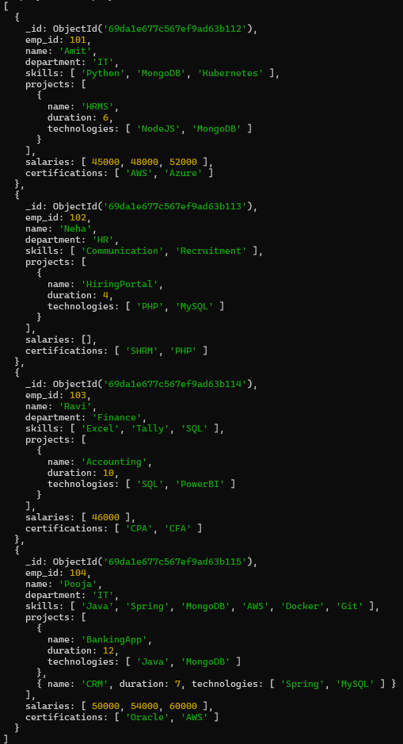

Que.9 :- Find employees who worked on MongoDB projects
Query :- db.employees.find({"projects.technologies":"MongoDB"})
Output :-
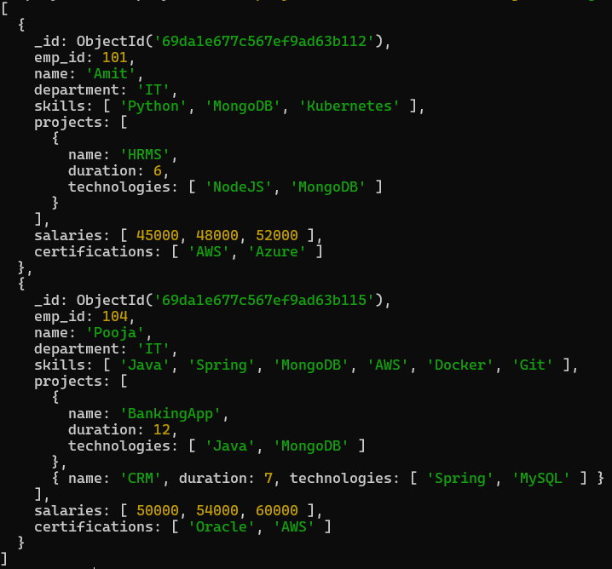
Que.10 :- Use $elemMatch to find project duration > 6 using MongoDB
Query :- db.employees.find({projects:{$elemMatch:{duration:{$gt:6},technologies:"MongoDB"}}})
Output :-
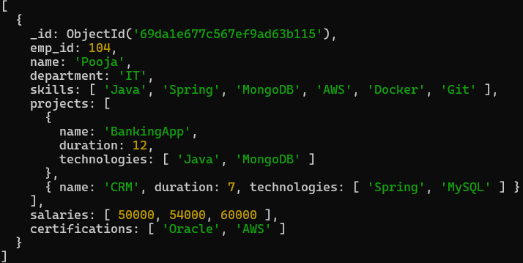
Que.11 :- Count number of projects for each employee.
Query :- db.employees.aggregate([{$project:{_id:0,emp_id:1,name:1,Total_project:{$size:"$projects"}}}])
Output :-
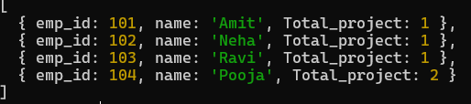
Que.12 :- Unwind skills array.
Query :- db.employees.aggregate([{$unwind:"$skills"}])
Output :-
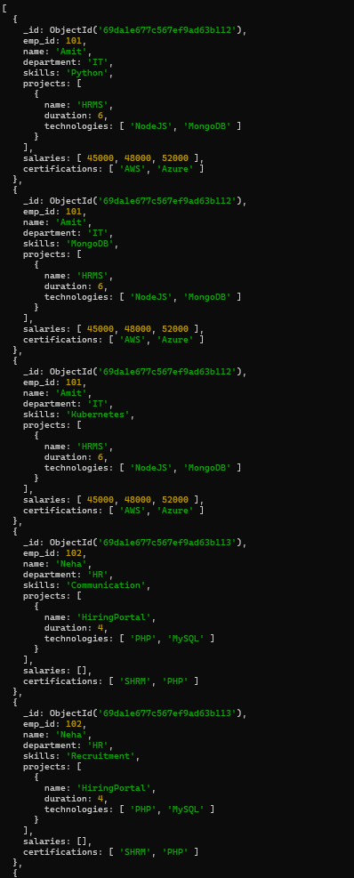
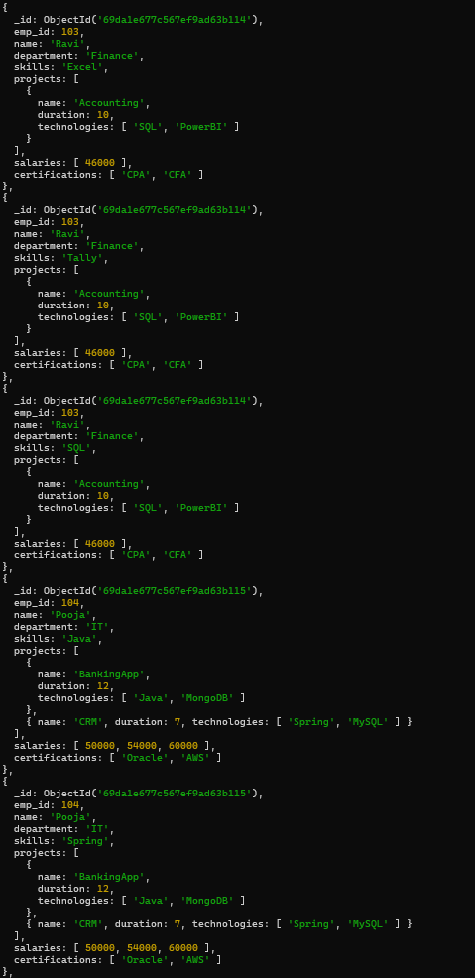
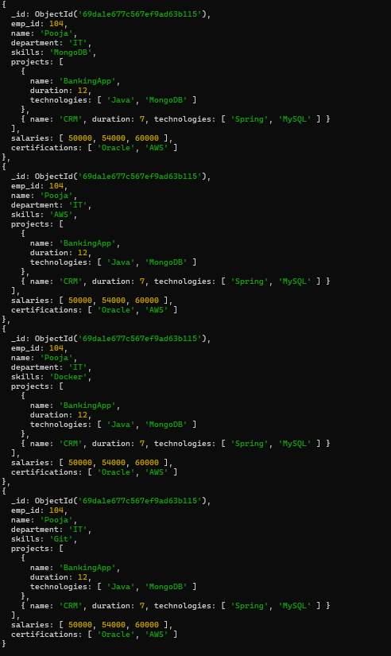
Que.13 :- List unique skills across company.
Query :- db.employees.distinct("skills")
Output :-
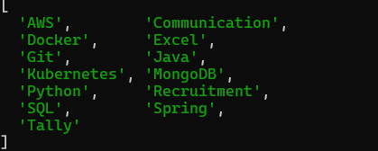
Que.14 :- Find employees with salary greater than 50000.
Query :- db.employees.find({salaries:{$gt:50000}})
Output :-
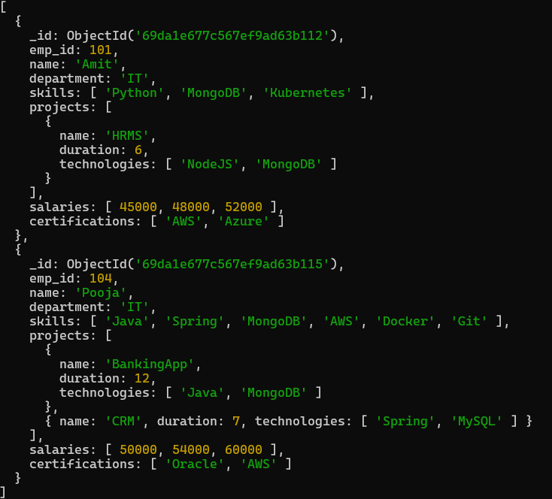
Que.15 :- Find employees with exactly 2 certifications.
Query :- db.employees.find({certifications:{$size:2}})
Output :-
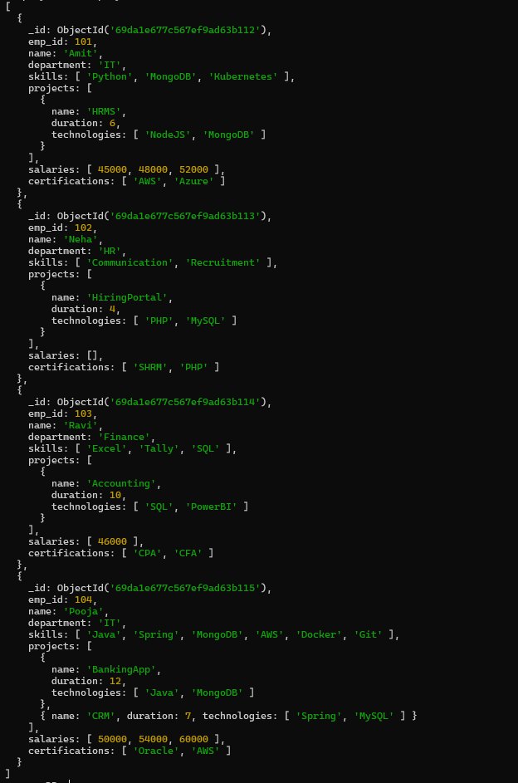
Que.16 :- Add new project to Ravi.
Query :- db.employees.updateOne({name:"Ravi"},{$push:{projects:{name:"TextBot",duration:5,technologies:["Excel","SQL"]}}})
Output :- {acknowledged: true,
insertedId: null,
matchedCount: 1,
modifiedCount: 1,
upsertedCount: 0}
Check Query :- db.employees.find()
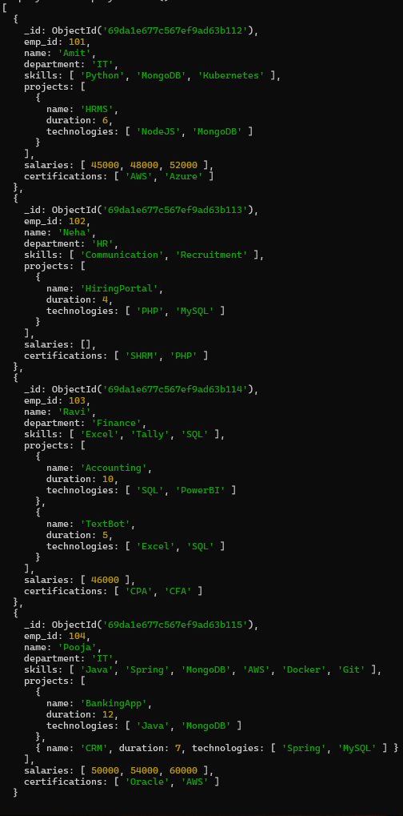

Que.17 :- Increase all salaries by 10% (array update).
Query :- db.employees.updateMany({},{$mul:{"salaries.$[]":1.1}})
Output :- {acknowledged: true,
insertedId: null,
matchedCount: 4,
modifiedCount: 3,
upsertedCount: 0}
Check Query :- db.employees.find()
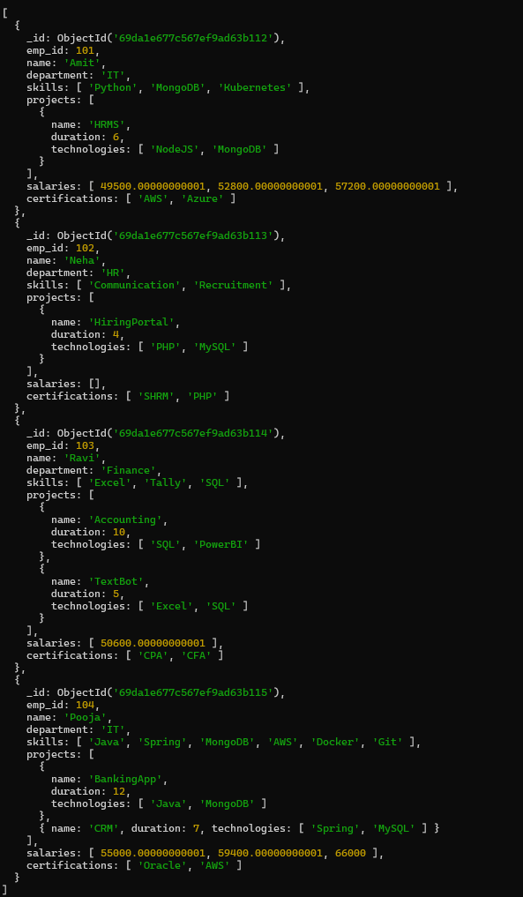

Que.18 :- Find highest salary of each employee.
Query :- db.employees.aggregate([{$project:{_id:0,emp_id:1,name:1,Highest_salary:{$max:"$salaries"}}}])
Output :-
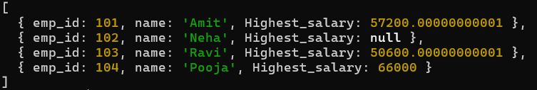
Que.19 :- Find average salary of employees.
Query :- db.employees.aggregate([{$project:{_id:0,emp_id:1,name:1,Avg_salary:{$avg:"$salaries"}}}])
Output :-
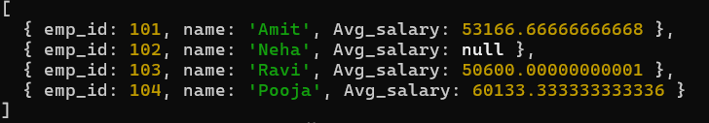
Que.20 :- Filter projects longer than 6 months.
Query :- db.employees.aggregate([{$project:{_id:0,emp_id:1,name:1,LongTermProject:{$filter:{input:"$projects",
as:"project",cond:{$gt:["$$project.duration",6]}}}}}])
Output :-
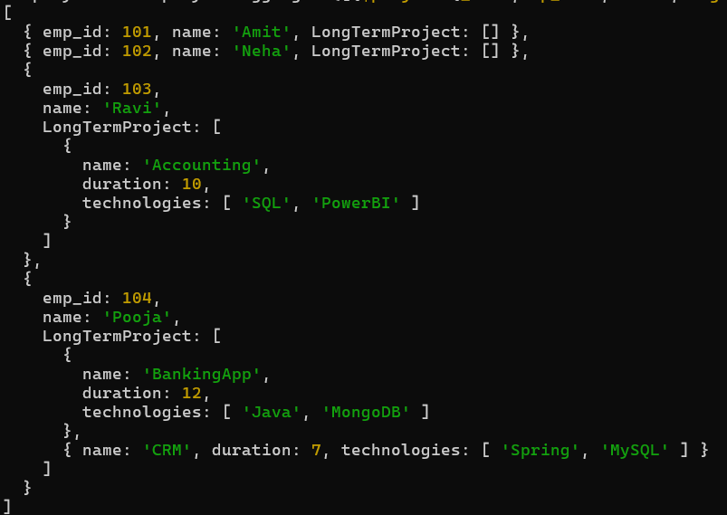

Que.21 :- Find employees who have any of these skills: Java or Python.
Query :- db.employees.find({skills:{$in:["Java","Python"]}})
Output :-
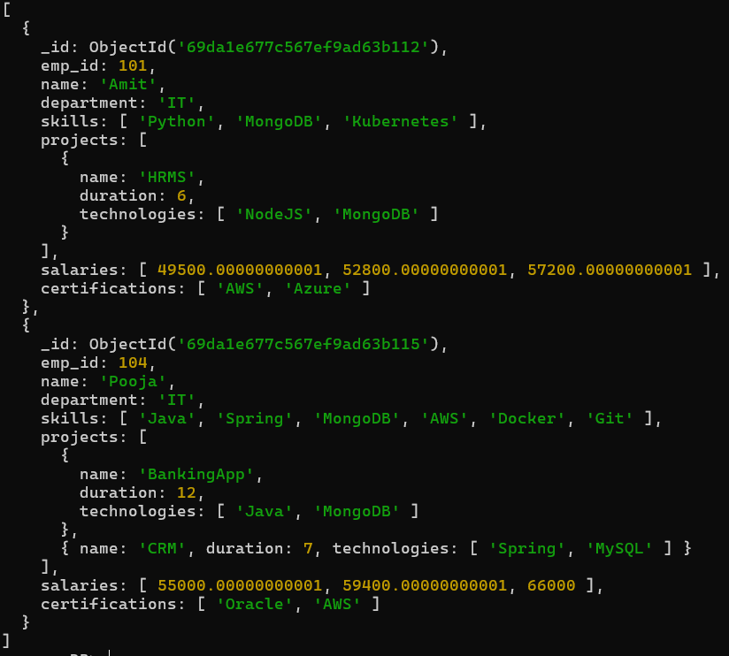

Que.22 :- Remove last salary entry.
Query :- db.employees.updateMany({},{$pop:{salaries:1}})
Output :- {acknowledged: true,
insertedId: null,
matchedCount: 4,
modifiedCount: 3,
upsertedCount: 0}
Check Query :- db.employees.find()
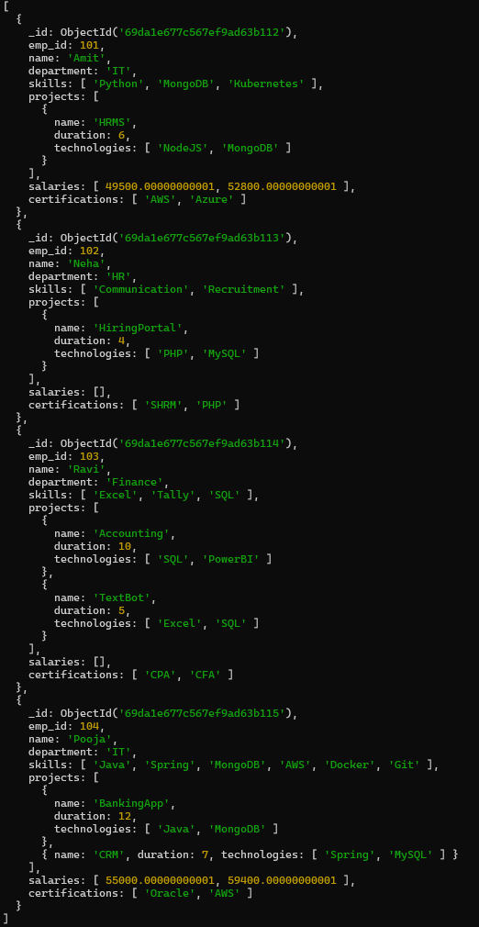

Que.23 :- Remove first salary entry.
Query :- db.employees.updateMany({},{$pop:{salaries:-1}})
Output :- {acknowledged: true,
insertedId: null,
matchedCount: 4,
modifiedCount: 2,
upsertedCount: 0}
Check Query :- db.employees.find()
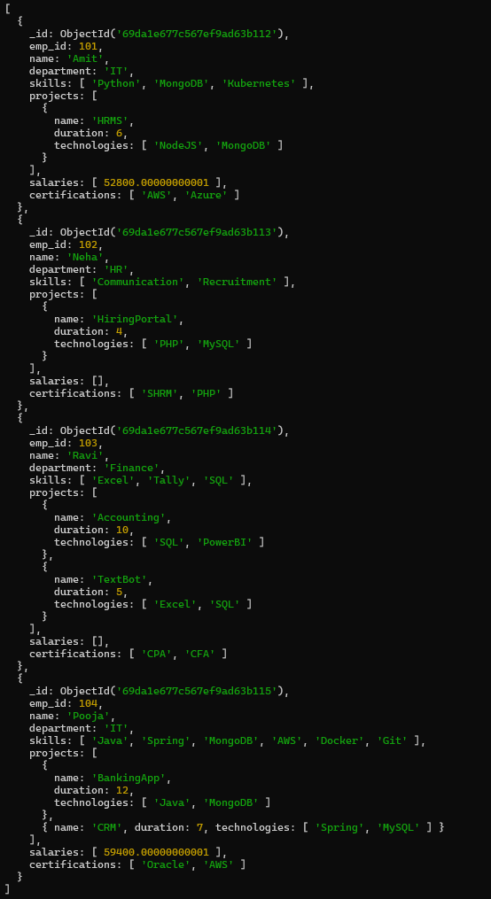

Que.24 :- Sort salaries array.
Query :- db.employees.aggregate([{$project:{name:1,sortedSalaries:{$sortArray:{ input:"$salaries",sortBy:1}}}}])
Output :-
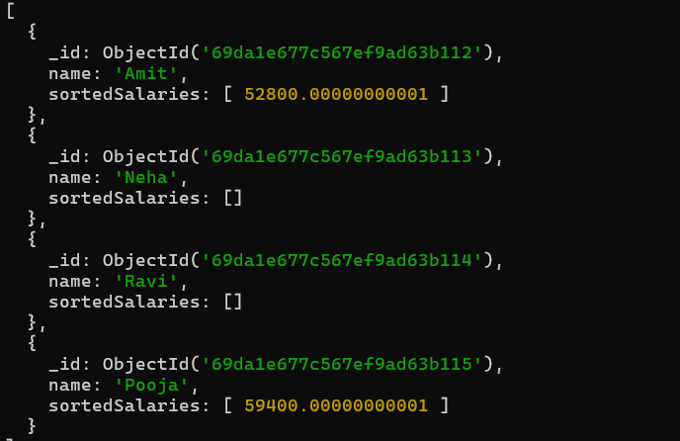
Que.25 :- Limit salaries array to last 2 entries.
Query :- db.employees.aggregate([{$project:{name:1,lastTwoSalaries:{$slice:["$salaries",-2]}}}])
Output :-
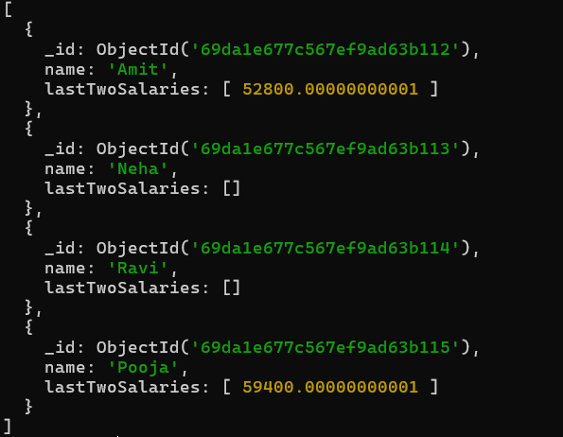
Que.26 :- Find total salary paid to each employee.
Query :- db.employees.aggregate([{$project:{_id:0,emp_id:1,name:1,Total_salary:{$sum:["$salaries"]}}}])
Output :-
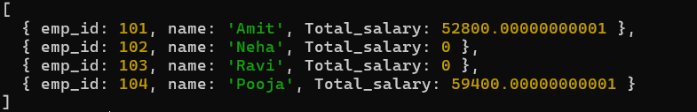
Que.27 :- Convert skills to uppercase.
Query :- db.employees.updateMany({},[{$set:{skills:{$map:{input:"$skills",as:"s",in:{$toUpper:"$$s"}}}}}])
Output :- {acknowledged: true,
insertedId: null,
matchedCount: 4,
modifiedCount: 4,
upsertedCount: 0}
Check Query :- db.employees.find()
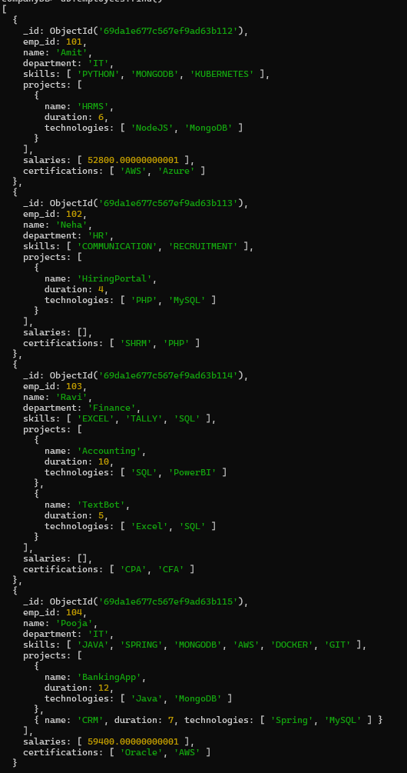

Que.28 :- Find employees with more than one project.
Query :- db.employees.find({$expr:{$gt:[{$size:"$projects"},1]}})
Output :-
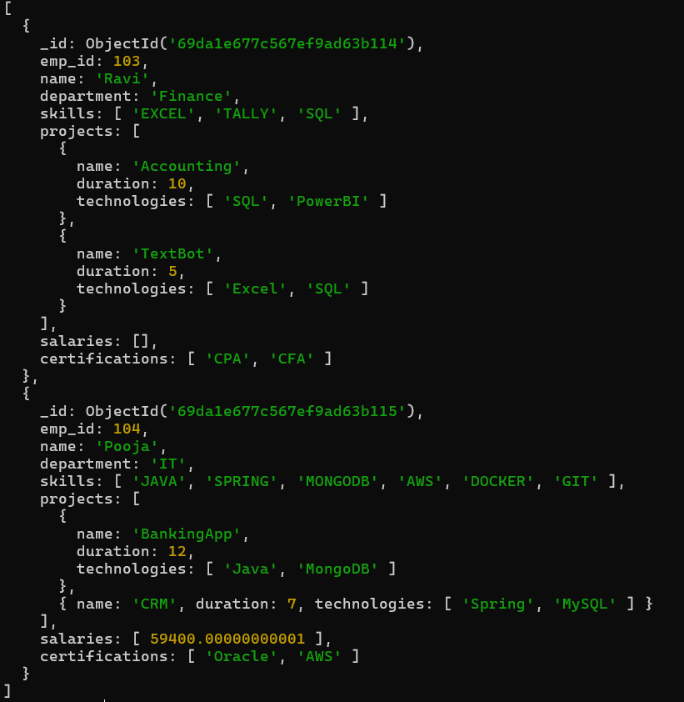
Que.29 :- Count employees per skill.
Query :- db.employees.aggregate([{$unwind:"$skills"},{$group:{_id:"$skills",Total_emp:{$sum:1}}},{$sort:{Total_emp:-1}}])
Output :-
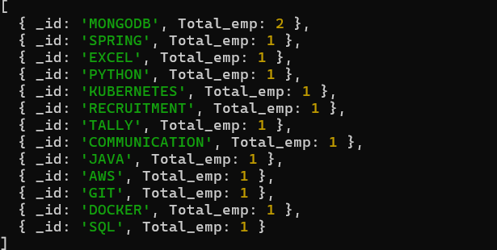
Que.30 :- Find employees whose all projects use MongoDB.
Query :- db.employees.find({projects:{$not:{$elemMatch:{technologies:{$ne:"MongoDB"}}}}})
Output :-
